

**STUDENT PROFILE**

**Sprint 1**

HALFWAY DOCUMENTATION – February 16, 2017

|  |  |  |
| --- | --- | --- |
| **SCRUM TEAM** | **SPRINT NAME AND DURATION** | **CHANGES** |
| HALFWAY | HALFWAY #1  February 7, 2017  to  February 16, 2017 | * **SP001 – SYSTEM FUNCTIONS** * **No Changes!** |

**SP001 – SYSTEM FUNCTIONS**

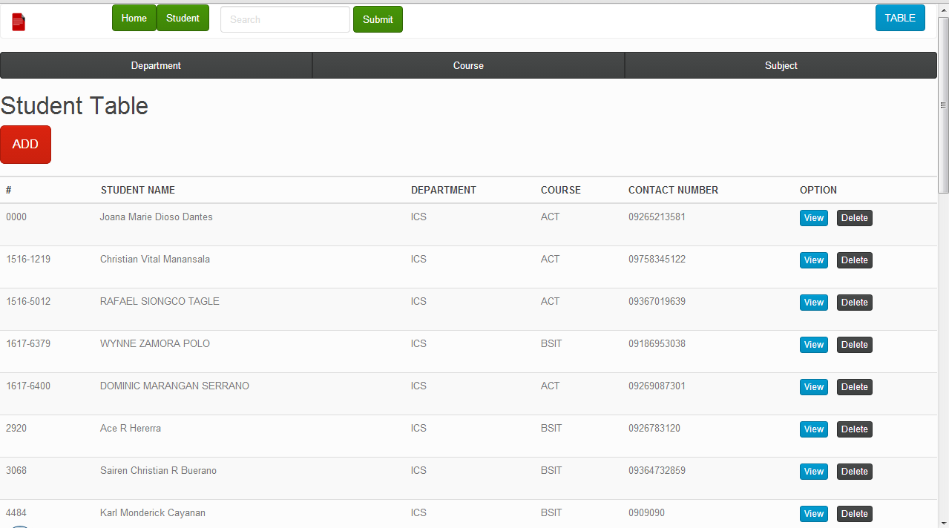

Features (Student Table)

1. Navigation bar – Use to link the other pages and a search bar for corresponding table.
2. Section Link – Use to navigate to view other commands or functions by their corresponding names.
3. Add Student Button – a link to view the add function of the student table.
4. Table – Use to be the output of the data by the corresponding names of the column.
5. View Button – use to visit the page of a certain data that can allow you to add, edit and delete.
6. Delete Button – use to delete corresponding data on a certain row.

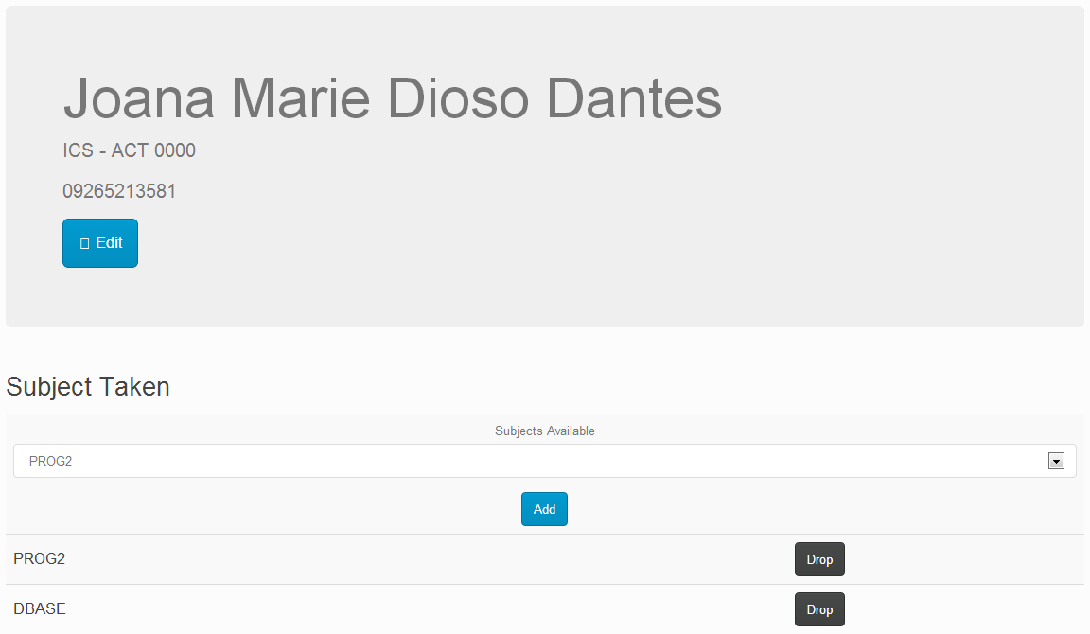

Features (View Page)

* View Page (Edit button) – allows you to edit a certain data.
* Subject Taken (Add button) – add a significant data that can be found on the database.
* Subject Taken (Drop button) – delete a certain data.

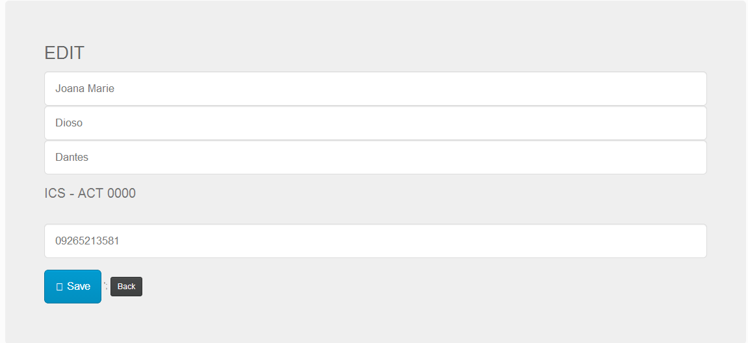

Features (View Edit Page)

* View Edit Page (Save Button) – allows you to save your modified data.
* Subject Taken (Back button) – link back to view page.

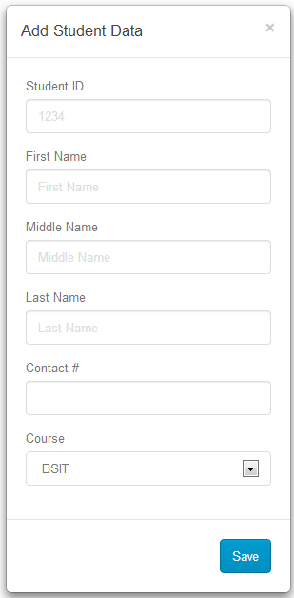

* Add Student Data – allows you to enter all the required data to be add on the database.
* Save button – allows you to save your data.

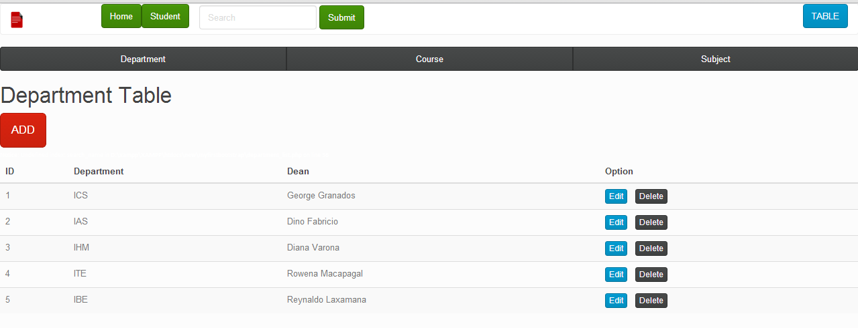

Features (Department Table)

* Navigation bar – Use to link the other pages and a search bar for corresponding table.
* Section Link – Use to navigate to view other commands or functions by their corresponding names.
* Add Button – a link to view the add function of the department table.
* Table – Use to be the output of the data by the corresponding names of the column.
* Edit Button – use to visit the page of a certain data that allows you to modify and save.
* Delete Button – use to delete corresponding data on a certain row.

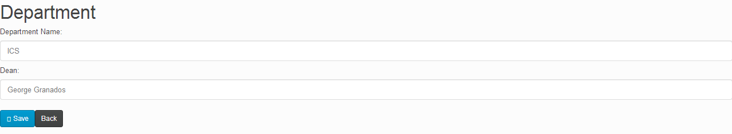

* Department Edit Page (Edit) – allows you to modify a certain data from the database.
* Save button – allows you to save your modified data.
* Back button – link to go back in Department Page.

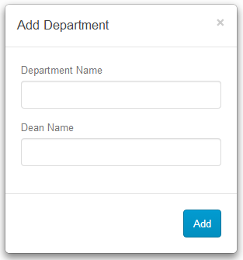

* Add Department Page (Add Department) – allows you to input required information to the database.

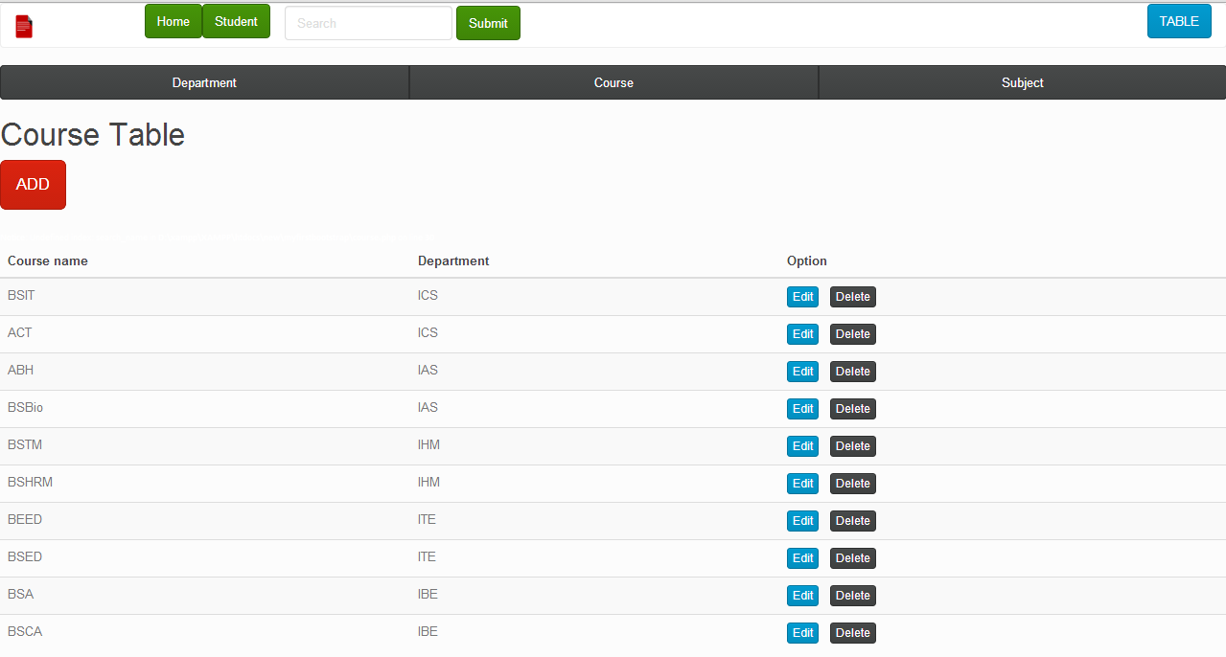

Features (Course Table)

1. Navigation bar – Use to link the other pages and a search bar for corresponding table.
2. Section Link – Use to navigate to view other commands or functions by their corresponding names.
3. Add Button – a link to view the add function of the department table.
4. Table – Use to be the output of the data by the corresponding names of the column.
5. Edit Button – use to visit the page of a certain data that can access for the other functions.
6. Delete Button – use to delete corresponding data on a certain row.

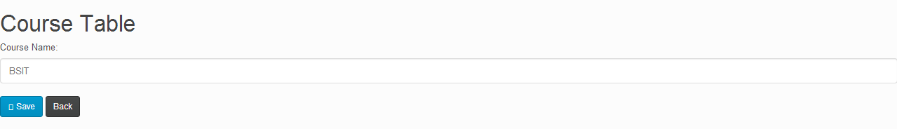

* Department Edit Page (Edit) – allows you to modify a certain data from the database.
* Save button – allows you to save your modified data.
* Back button – link to go back in Department Page.

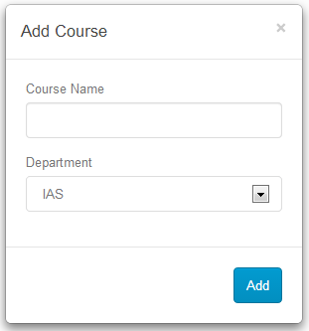

* Add Course Page (Add Department) – allows you to input required information to the database.

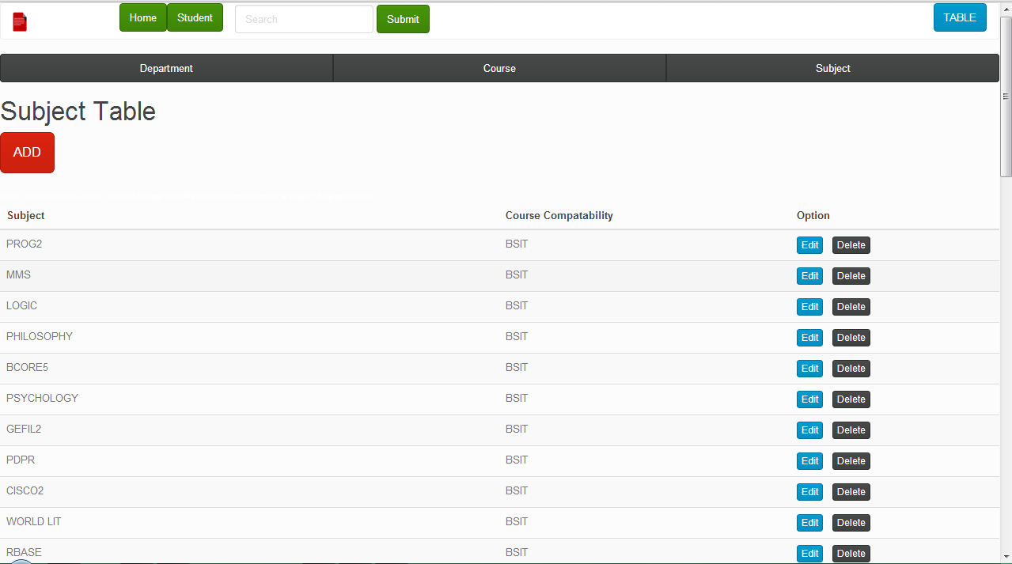

Features (Subject)

1. Navigation bar – Use to link the other pages and a search bar for corresponding table.
2. Section Link – Use to navigate to view other commands or functions by their corresponding names.
3. Add Button – a link to view the add function of the department table.
4. Table – Use to be the output of the data by the corresponding names of the column.
5. Edit Button – use to visit the page of a certain data that can access for the other functions.
6. Delete Button – use to delete corresponding data on a certain row.

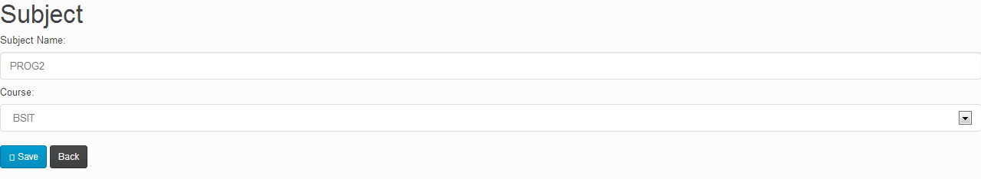

* Subject Edit Page (Edit) – allows you to modify a certain data from the database.
* Save button – allows you to save your modified data.
* Back button – link to go back in Department Page.

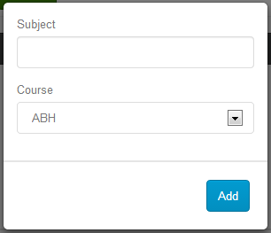

* Add Department Page (Add Subject) – allows you to input required information to the database.